Swagger Setup in Node.js

Prerequisites:

1. Node.js Application already setup

Setup:

1. Do npm install swagger-node-express
2. Go to node_modules and open the dependency node-swagger-express . You will see a folder named swagger-ui as shown below

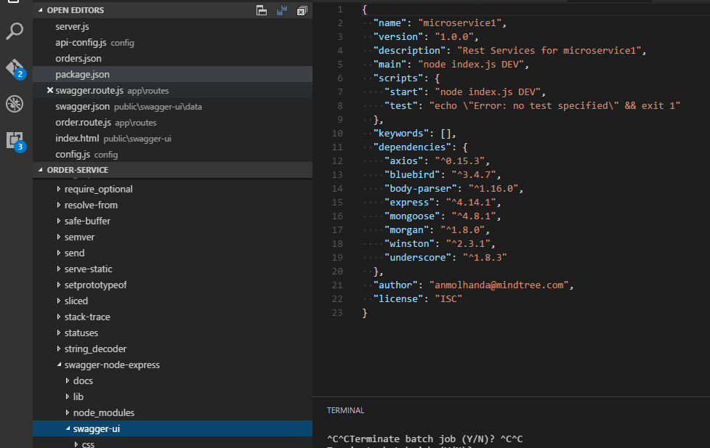

1. Create the public folder in project workspace only and copy the swagger-ui folder to that particular folder.

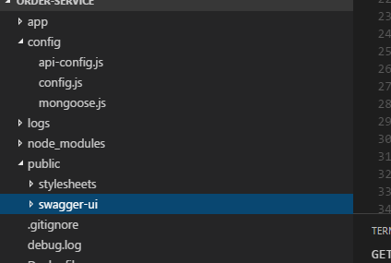

1. Require these files , where you are doing the routing , change the path of the swaggerFile accordingly



Also, use the below piece of code as middleware in your node.js code in order to tell your application to serve the swagger from the mentioned directory

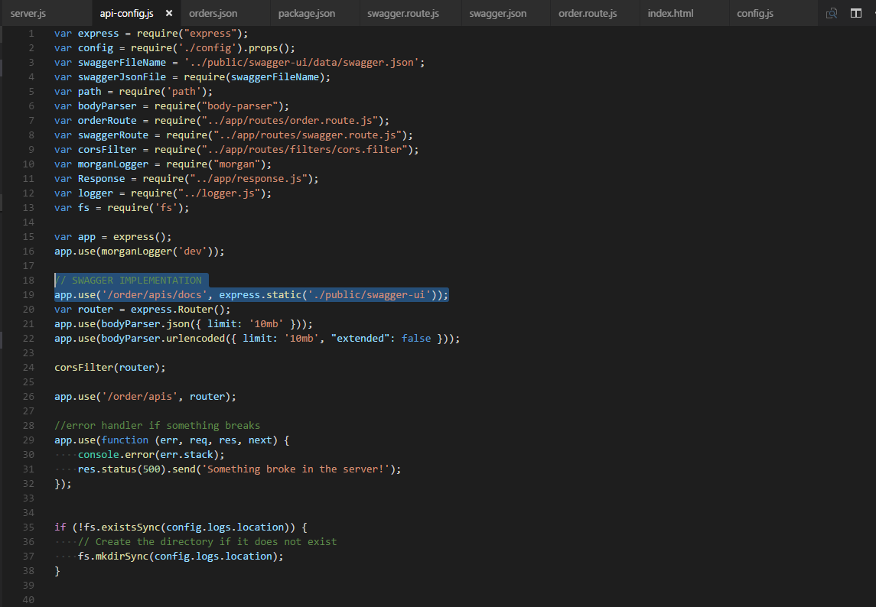

Here highlighted text helps in accessing the swagger-ui as an api on **/order/apis/docs** and **/order/apis** is static part in url which is added before each API call as it is added as a static route in line number 26 in above image.

1. Add a route for swagger JSON also in order to read the swagger JSON in our swagger-ui.

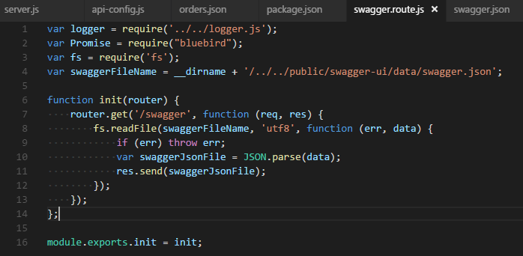

You will see the JSON , once you hit this API as shown below

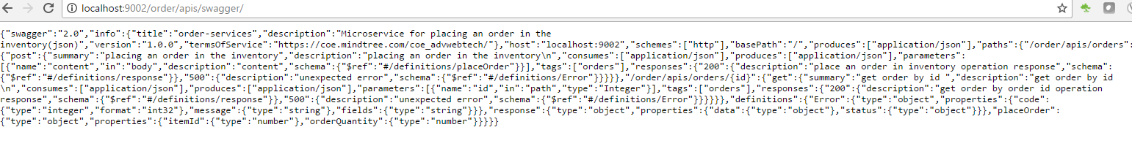

1. Go to /public/swagger-ui/index.html and change the url according to the route added in step 5 for reading swagger.json . For me my API for swagger JSON will be hit at /order/apis/swagger, so my url in index.html is set as shown below

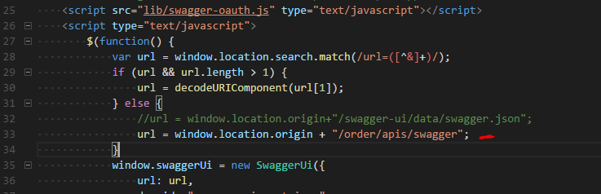

1. Now go to /public/swagger-ui/data/swagger.json and start adding your own API Documentation in swagger , basic swagger.json looks like following : 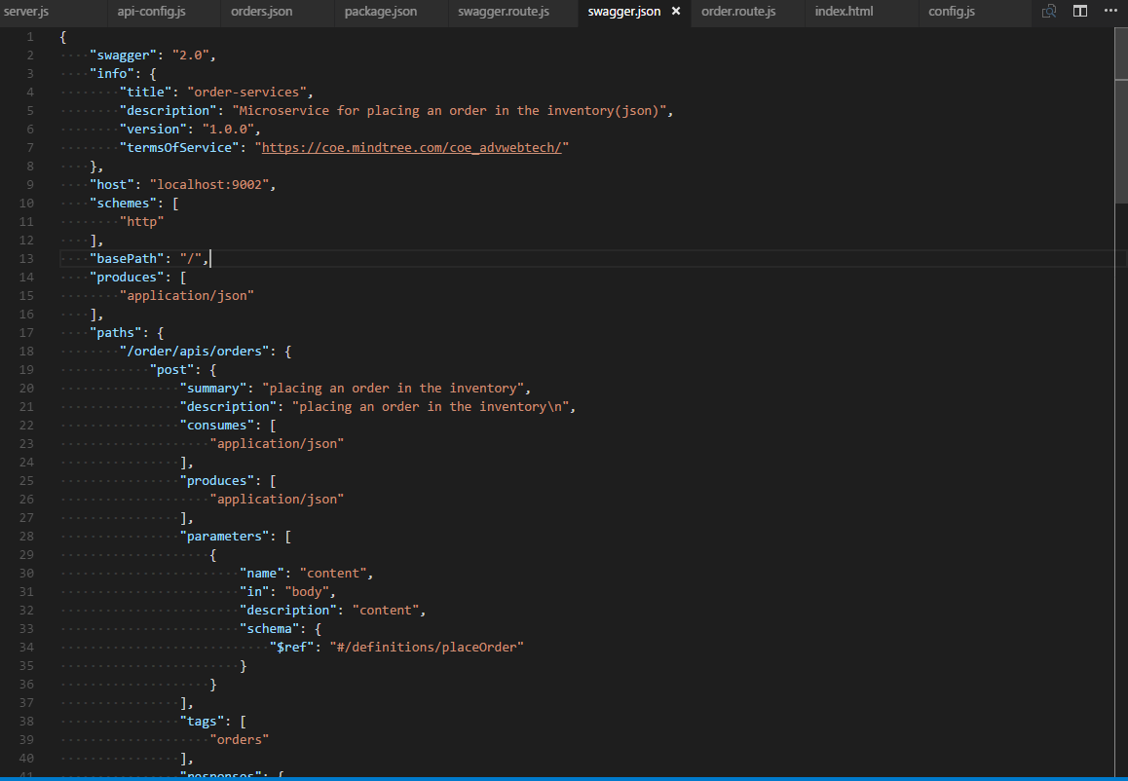

Here we can mentioned the host , swagger-info and then in in paths , we can add our APIs

1. Refer to the code Repository at <https://github.com/handaanmol/order-service> for seeing the codebase and to setup a node application integrated with Swagger-UI. Swagger-UI will help us to understand the functionality of the APIs in a better way with expected request and expected response mentioned there .

It looks like as shown below :

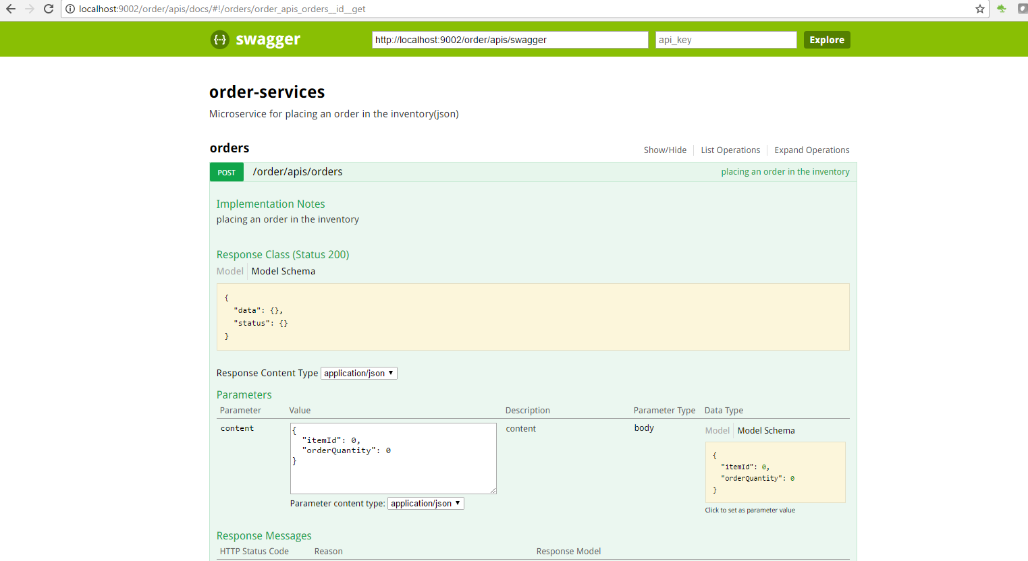

The URL for this swagger on local is : <http://localhost:9002/order/apis/docs>

1. Adding new API in swagger (say to get all orders- **localhost:9002/order/apis/orders**)

Inside paths object in swagger JSON file, add your new path as shown below

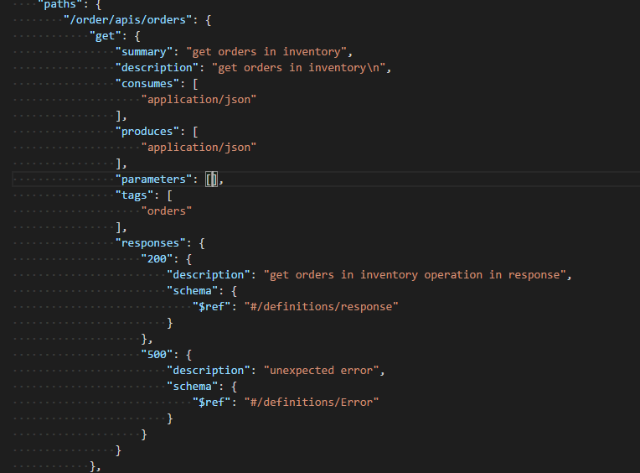

Since here, there is no path variable or query param which is needed, we didn’t add anything in parameters attribute is an empty array.

1. Now we will restart our application and see whether the new API is reflected on swagger or not and we observe the following change on swagger-ui

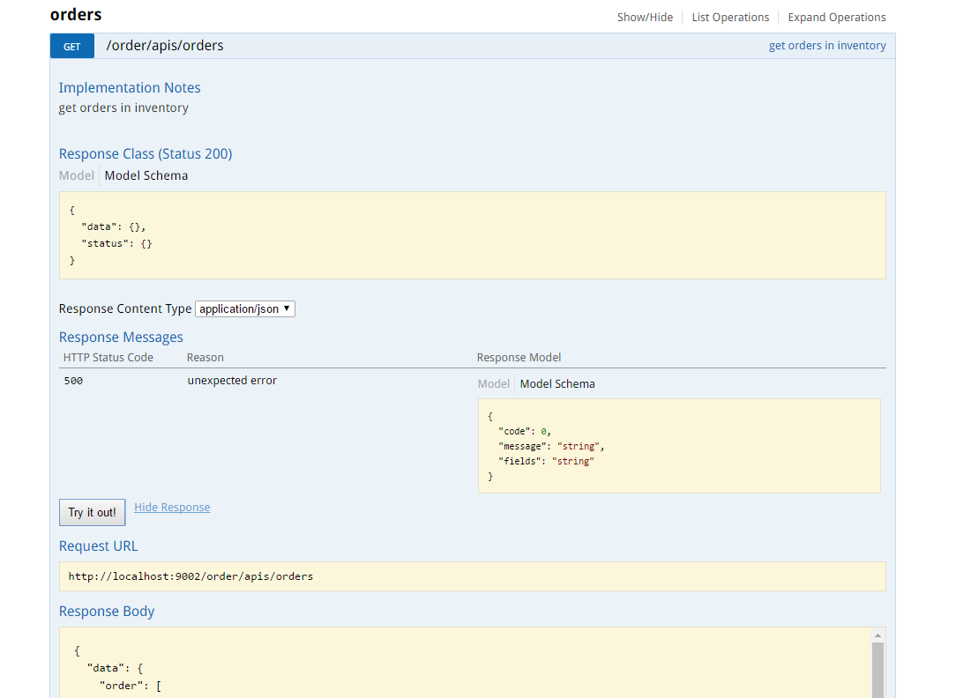

This means the change we did for new API in swagger JSON has been reflected successfully on swagger-ui.